Technical Specification - EMMA Enhancement

IDOC and MR document intégration in EMMA
&
automatic resolution to the exceptions

Functional Team: | CCS Back Office
Document Writer(s): | Hasnain Jaffery
Legacy Programmer:
SAP Programmer: | Hasnain Jaffery
Interface ID:
Message Class:

Version | Change | Date | Changed by
1.0 | Initial Revision

Reviewer Title | Role | Name | Date Reviewed
Process Team Lead | Review * | Joseph Guscinski
Process Team Lead – DC | Review * | Jeff Yankley
Functional Spec Author | Review* | Manuel Beltrandelrio
Development Lead | Approve | Hasnain Jaffery
Development Lead - DC | Approve

Review * A technical specification review meeting will be held where the specification will be either approved by those with (Review *) status or else it will go through revisions as suggested in the meeting and approved later.

1. Functional Summary of Integration
As part of System automation and analysis the following will be performed
- IDOC analysis summary report
- Automatic resolution to IDOC errors
- Automatic resolution to MR implausible documents
- New case categories to identify the IDOC and MR errors

1.1 Functional Specification Name

2. System Diagrams

2.1 Architecture
EMMA will analyze upload IDOCs and MR documents and will built the statistics based on its current status. For any exception, a case will created and based on the automatic resolution defined system will try to resolve the case. In case of success, case will be closed and thus status of IDOC will be changed to 51.

2.2 Process Flow: MR & IDOC processing through EMMA
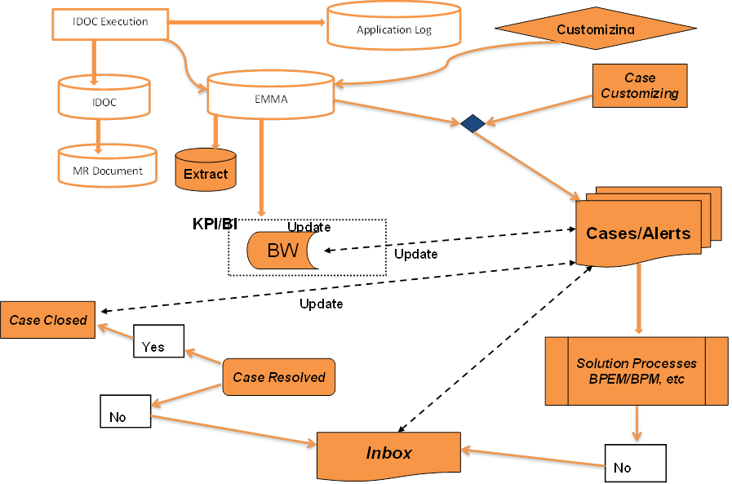

3. Development Objects
This section will talk about all the development done to achieved the automatic resolution process

3.1 Repository Objects
All the objects developed belongs to a new package ‘ZEMMA’

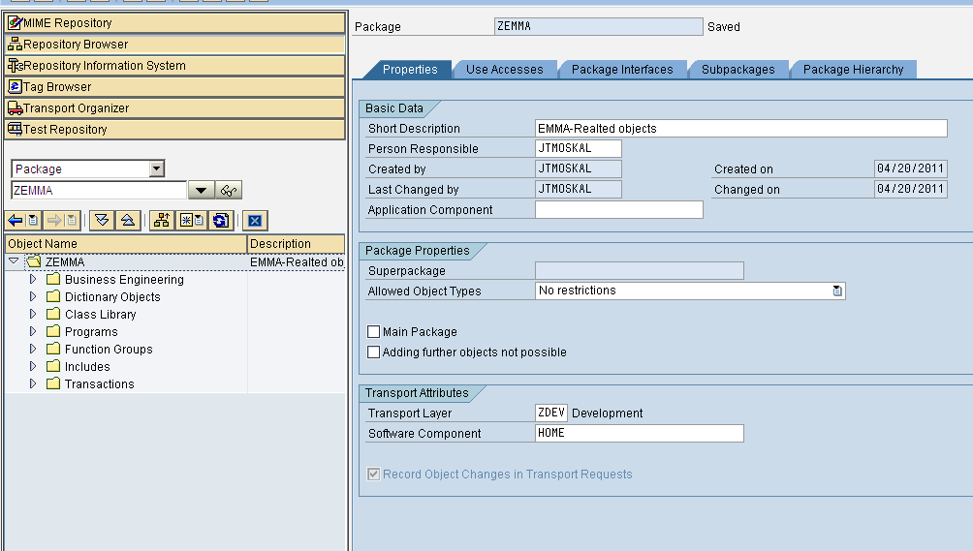

3.1.1 SLD Components
Component | Name | Description
Product
Software Component Version

3.1.2 Data Types
Data Type Name | Description

3.1.3 Message Types
Message Type Name | Data Type (s) Associated | Description

3.1.4 Message Interfaces
Message Interface Name | Async/Sync | Message Type (s) Associated

3.1.5 Message Mappings
Message Mapping Name | Source Message Type | Target Message Type

3.1.6 Interface Mappings
Interface Mapping Name | Source Message Interface | Target Message Interface

3.1.7 Business Process Management (BPM)
BPM Name | Source Message Interface | Target Message Interface

3.2 Directory Objects
Total of 121 new objects have been created for the package ‘ZEMMA’ the list is attached

3.2.1 Scenario
Scenario Name | Description

3.2.2 Receiver Determination
Receiver Determination Name | Interface Determination Name | Receiver Agreement Name

3.2.3 Interface Determination
Interface Determination Name | Interface Mapping Name

3.2.4 Receiver Agreement
Receiver Agreement Name | Communication Channel Name

3.2.5 Sender Agreement
Sender Agreement Name | Communication Channel Name

3.2.6 Sender Agreement
Communication Channel Name | Adapter Type

4.0 Development Objects
Total of 121 new ‘Z’ objects have been created under the package ‘ZEMMA’

4.1 Inbound Interface
4.12. New Tables / Structures / EDI Segments
Table Name:
Key | Field Name | Data Element | Description | Check  Table | Type | Length

4.13. New Data Elements
Data Element | Description | Domain | Parameter ID

4.14. Programs, Reports, Function Modules etc.
Reports: ZIDOCSTATANALYSIS, ZREADIDOCDETAILS, ZCONTRACTBLOCK, ZEMMAMRUPLDDOC, ZIDOCSTATANALYSIS
Transactions: ZIDOCANALYSIS, ZMRIDOC, ZBILLBLOCK
Function modules: ZIDENTFY_REGISTER, ZSHOW_CHANGE_DOC_NOTIFICATIONS, ZMRDOC_HISTORY_EL31

4.2 Outbound Interface
None

5.0 Adapters

5.1 JDBC Adapter
Property | Value
Type | <Sender/Receiver>
Driver Type | <DB2, Oracle, SQLServer>
Stored Procedure Name
SQL Statement
Polling Time | <Optional>
Update Statement

5.2 FTP Adapter
Property | Value
Type | <Sender/Receiver>
Directory/FTP Site | <DB2, Oracle, SQLServer>
File Name
Encryption Required | <Yes/No>
Polling Time | <Optional>

5.3 RFC Adapter
Property | Value
Type | <Sender/Receiver>
RFC Name | <DB2, Oracle, SQLServer>
SAP SID

5.4 SOAP Adapter
Property | Value
Type | <Sender/Receiver>
Web Service Name
URL/WSDL File Location

5.5 HTTP Adapter
Property | Value
Type | Receiver
URL

5.6 IDOC Adapter
Property | Value
Type | Receiver
IDOC Name
SAP SID’s Used

5.7 Third Party Adapter
Property | Value
Type | <Description>
Type | <Sender/Receiver>
Adapter Specific Properties | <This information will vary based on each adapter, but should be as complete as possible>

6.0 Transformation/Mapping
This area describes the specific information about the transformation and mapping involved in each interface. This detail includes but is not limited to, input and output data type definitions (DTD), a graphical mapping representation of the elements (could be embedded mapping spreadsheet), any interface specific library functions or external programs.

6.1 Data Types
<Input and Output Data Types will be listed here. Formats for each interface will vary, and the detail of each listing will be left to the discretion of the author. Complex DTD’s should be listed in detail and associated with this document. Simple DTD’s should be listed here to reduce the amount of documents technical personnel needs to assemble to get a complete picture of the interface.>

6.2 Data Type Mapping
<The data type mapping will be listed here. The specific format of each mapping diagram may differ due to data type differences, but if a template exists for interfaces like File to RFC for example it will be used.>

6.3 External Transformation Programs
<Any external programs, engine stubs, library functions, will be listed here. The procedure name, the location of the resource, and a brief description of the logic will be listed here.>

7.0 Legacy System Interface Overview
<This section is an overview of the Legacy System interface process. Include any detailed information that gives and understanding of the logic around the extract process. If the information will come from or to multiple systems, show how this will be brought together and where it will be located. about. If diagrams and flow logic will help clarify the process, put these diagrams in this section. Are any special tools used for this process or should be used? >

7.1 File Based Interface - File transfer File location
<How will the file or table become available to SAP – will it be through a staging area? Will it be through an Oracle table? How will the data get to this location and what will the location of the data be? >

7.2 List of Files / Tables <Include a short list of the files / Tables that will be created. Indicate type of file: Input, output, translation, control etc>
File / Table Name | Location | Description and type of Files / Table

7.3 Program Information [Legacy]
Program Name | Language | Description of Function

7.4 Describe Version Control and Error Reports [Legacy]
<How do we keep track of the current version of the software that is being used. What type of errors are reported and how are they reported? >

7.5 Comments [Legacy Interface]
<Any extra information that should be taken notice of with regards to the legacy system interface details. >

8.0 Security
This area summarizes the security requirements of an interface and document how those requirements are being met. This will include but is not limited to: summary of sensitive datatypes and service users. The Sensitive Data Summary section will alert technical personnel to sensitive information, and the Service Users section will list planned Service Users for the integration.

8.1 Sensitive Data Summary
<Notifications of sensitive data>

8.2 Service Users
Service User ID | Description of Use
<ZSDAPPSUSER> | <This user is used to post sales orders>

9.0 Error Handling
This area outlines the error handling process for each interface. The information will include error messages, their delivery media, and error logging. The detail of the error handling in a process will be left to the author’s discretion to provide. Programming errors such as handling null values, referring to an invalid index in an array, or other problems which might cause a short dump should not be listed here.

9.1 Error Messages
Error Name | Property | Value
CUST_NOT_FOUND | <Location> | <Receiver Proxy in DEV1 (SID)>
CUST_NOT_FOUND | <Error Cause> | <Customer Number is not found in R/3 because the customer number is missing or the customer number was entered incorrectly>
CUST_NOT_FOUND | <Error Handler> | <Errors are inserted into a database for user evaluation later>
SALESORG_NOT_FOUND | <Location> | <Receiver Proxy in DEV1 (SID)>

  - 10. Unit Test Plan

Item # | Description | Steps Performed | Expected Results | Actual Results | SNET, Sand, Dev, QAS | Complete (Y/N)
1
2

